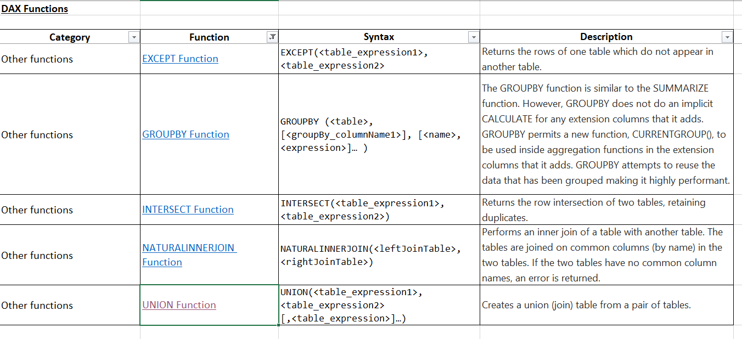

CombineTwoTables = UNION('DrivingSafely2015','DrivingSafely2016')

CombinedStates = UNION(

SELECTCOLUMNS(DrivingSafely2015, "State", DrivingSafely2015[State]),

SELECTCOLUMNS(DrivingSafely2016, "State", DrivingSafely2016[State])

)